Assignment 4

Understanding Arduino UNO R3 Pinouts

1.Introduction
Arduino UNO R3 is a widely adopted microcontroller board employed in electronics studies and IoT applications. The Arduino UNO R3 consists of the ATmega328P microcontroller and serves as a straightforward microcontroller board to construct an embedded system.
In order to use the Arduino UNO R3 efficiently, it is crucial to comprehend the available documentation of the board like Pinout, Datasheet, Schematics, and Cad. Out of all these, Pinout (in PDF format) is the one that holds importance for beginners.

2. Understanding Key Documentation Terms (Arduino Perspective)
- Pinout (PDF)
  - Graphic diagram containing all the pins on the Arduino board
  - Indicates:
    - Digital pins
    - Analog pins
    - Power pins
    - Communication pins
  - Assists the user in determining the pin that should be used for particular purposes

- Considered the most crucial documentation for beginners as it is helpful when connecting circuits.

- Datasheet
  - Technical documentation of the microcontroller (ATmega328P)
  - Provides information about:
    - Electrical specifications
    - Voltage levels
    - Timing diagrams
    - Chip architecture

- Used for thorough analysis and design process.

- Schematics
  - Circuit diagram of the Arduino board
  - Describes the internal structure of the components within the board
  - Consists of various parts such as resistors, capacitors, microcontroller, etc.

- Used for analyzing and troubleshooting problems.

- CAD Files
  - Computer-Aided Design files for the Arduino board
  - Used in software such as AutoCAD and Fusion 360

3. Arduino UNO R3 Pinout (Detailed Explanation)
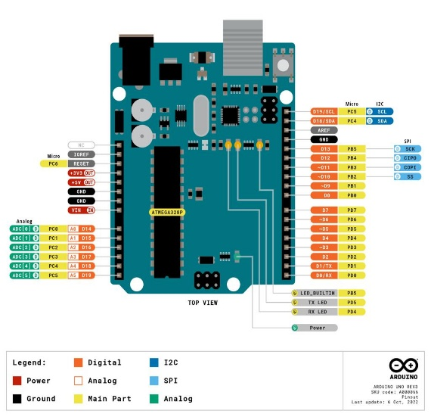

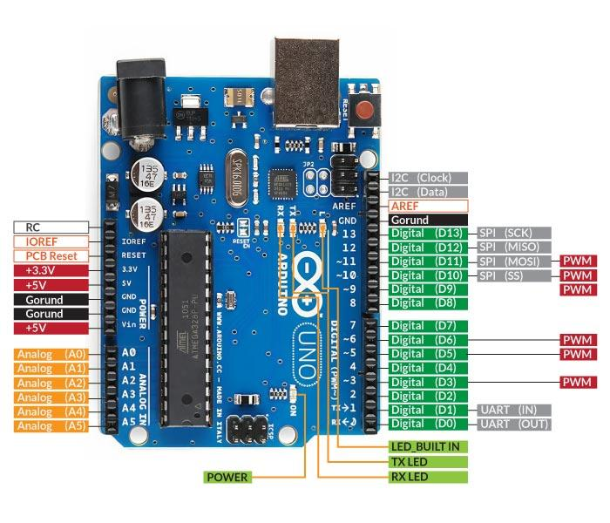

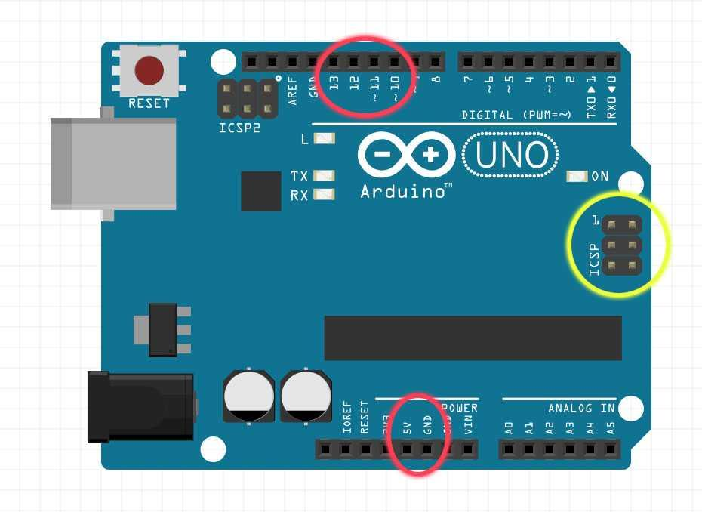
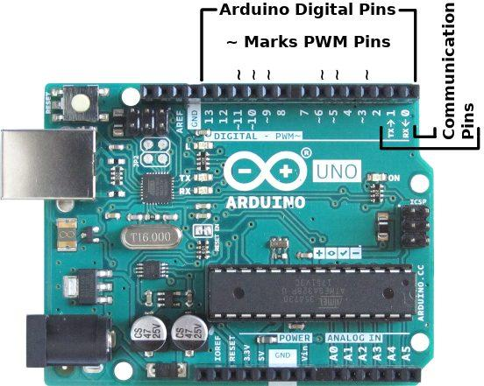
The Pinout (PDF) shows the configuration of all the pins on the board.
- Digital Pins (0-13)
  - It is used for digital input/output
  - It can detect HIGH (1) or LOW (0)

- Special Digital Pins
  - PWM Pins (3, 5, 6, 9, 10, 11)
    - It is used for analog-like output (such as LED brightness)
  - Serial Communication
    - Pin 0 (RX) and Pin 1 (TX)

- Used in LEDs, switches, motors, and communication

- Analog Pins (A0-A5)
  - Used for reading analog signals (0-5V)
  - Converting analog signals to digital values

- Used for sensors such as temperature, light, etc.

- Power Pins
  - 5V - It provides 5V power
  - 3.3V - It provides 3.3V power
  - GND - Ground
  - Vin - Power input from external sources

- Used to provide power to sensors and modules.

- Communication Pins
  - I2C Communication
    - SDA (A4), SCL (A5)
  - SPI Communication
    - Pin 10 (SS), Pin 11 (MOSI), Pin 12 (MISO), Pin 13 (SCK)

- Used to connect modules such as display, sensor, etc.

- Other Important Pins
  - AREF
    - Analog reference voltage
  - RESET
    - Resets the board

- Important for control and stability.

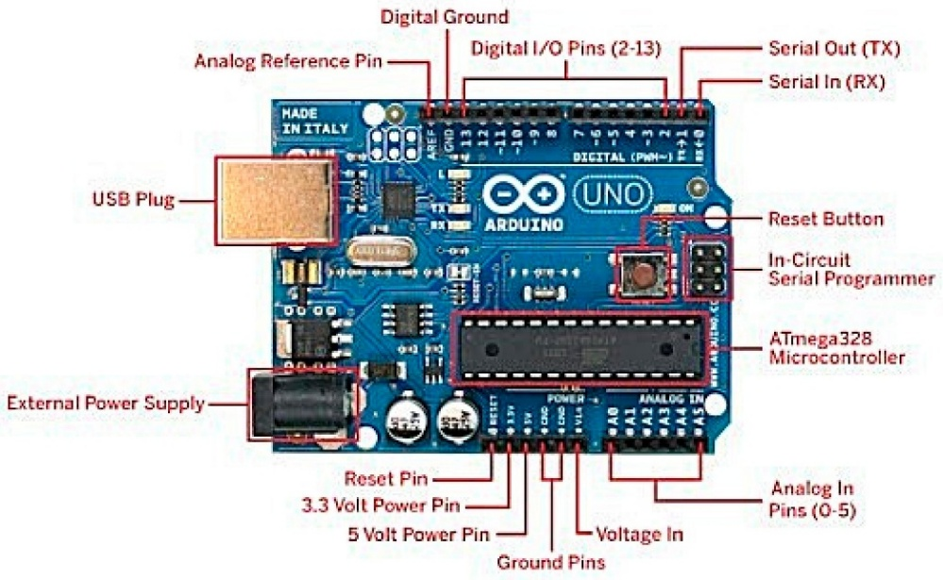
4. Features of Arduino UNO R3
- Based on ATmega328P microcontroller
- 14 digital I/O pins
- 6 analog input pins
- 16 MHz clock speed
- USB interface for programming
- Easy to use for beginners
Makes it ideal for learning embedded systems and IoT projects.

5. Tutorials and Learning Support
- Arduino provides official tutorials for:
  - LED blinking
  - Sensor interfacing
  - Motor control
- Helps beginners understand practical usage of pins.
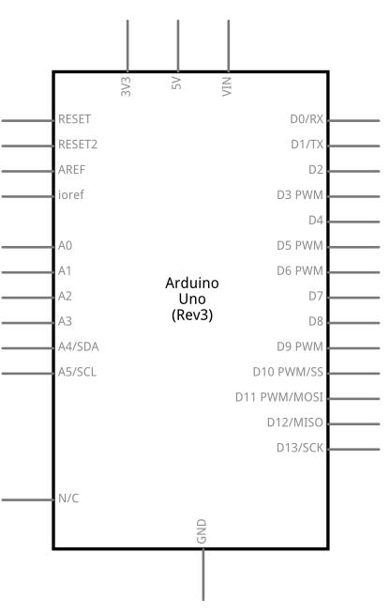
6. Technical Specifications
- Operating Voltage: 5V
- Input Voltage: 7–12V
- Flash Memory: 32 KB
- SRAM: 2 KB
- EEPROM: 1 KB
Important for designing efficient projects.

7. Compatibility
- Compatible with:
  - Arduino IDE
  - Various shields (motor shield, Wi-Fi shield, etc.)
  - Sensors and modules
Ensures flexibility and wide usage.

8. Suggested Libraries
- Built-in Arduino libraries:
  - Wire (I2C communication)
  - SPI (SPI communication)
  - Servo (motor control)
Libraries simplify coding and hardware interaction.

9.Conclusion
The Arduino UNO R3 is a robust and beginner-friendly development board. Knowledge of the UNO R3's Pinout (PDF) is critical when working with hardware components; however, the Datasheets, Schematics, and CAD files offer much more than that.
- Pinout assists in utilizing pins practically
- Datasheets contain technical information
- Schematics describe inner circuits
- CAD files aid in designing and modeling
- Arduino UNO R3 is used in IoT

